Assignment2
NAME:Sara Bin Shayhun ID:s22108018
Part1:
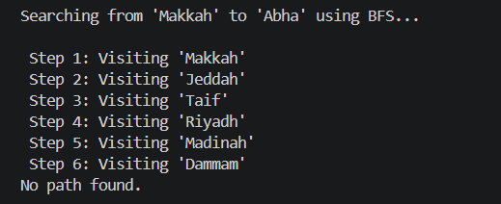

Answer 1 – Your New City:
The name of the city I added (TODO 2):
City name: Abha
It is connected to: Jeddah and Riyadh
Answer 2 – BFS Result:
Fill in the blanks using what you saw in the terminal output.
a. BFS started at: Makkah
b. BFS was looking for: Abha
c. The path BFS found was: Jeddah → Taif → Riyadh → Madinah
(add more arrows if your path is longer)
d. The path had 0 steps (hops) in total.
e. Did BFS visit any cities that were NOT on the final path? Yes □ No □
If yes, name one: Jeddah
f. Why does BFS visit extra cities that are not on the final path?
Because BFS explores all neighboring cities level by level while searching for the destination, so it may visit extra cities even if they are not part of the final path.

Part2:
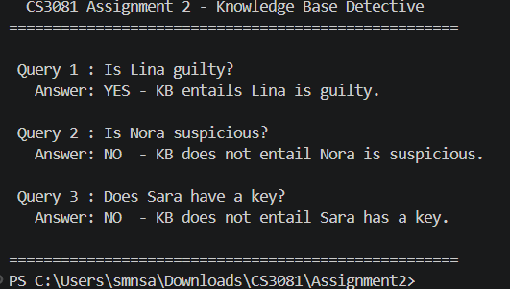

Answer 3 – Query Results:
Write the answer your program printed for each query.
- Query 1 – Is Lina guilty?
- Program answered: YES □ NO □
- b. Query 2 – Is Nora suspicious?
- Program answered: YES □ NO □
- c. Query 3 – Does Sara have a key?
- Program answered: YES □ NO □
Answer 4 – Understanding the Results:
a. Why is Lina guilty according to the KB? (Trace the clues: which clues lead to this conclusion?) Because the KB rules prove Lina is guilty.
b. Clue 5 says Nora HAS an alibi. Yet Query 2 asks if she is suspicious. Based on the program’s answer – is she suspicious? In your own words, why? No, because Nora has an alibi.
c. Complete this sentence in your own words: “The Knowledge Base cannot prove a statement unless . . . ” there is enough evidence in the KB.

Reflection – Search vs. Knowledge:
In Part 1, BFS searched for a path. In Part 2, the KB deduced a fact.
What is the difference between what BFS does and what the KB does? Think about: What is the input? What is the output? What kind of problem does each solve?
BFS searches for a path between cities using a graph and returns a route if found. The Knowledge Base uses facts and rules to deduce whether a statement is true or false. BFS solves path-finding problems, while the KB solves reasoning problems.

